***EE/CprE/SE 491 WEEKLY REPORT 6***

***10/18/24 - 10/24/24***

***Group number: sdmay25-07***

***Project title: Ask Captain Cyber***

***Client &/Advisor: Doug Jacobson***

***Team Members/Role:***

* ***Ethan Comiskey - Cybersecurity Implementation Principal Manager***
* ***Steven Ragan - Cybersecurity Coordinator & Integration Associate***
* ***Alex Elsner - Lead backend developer***
* ***Casper Run - Cybersecurity and WordPress developer***
* ***Alexander Kronau - Backend developer. Limited Frontend***
* ***Caden Murphy - Frontend developer***

**Weekly Summary**

The goal for this week was to finalize our designs and begin our implementation of Ask Captain Cyber. In Figure 1, we have our team’s tentative design of the main UI page of Ask Captain Cyber. In Figure 2, the database plugin we are considering integrating into our project is shown. We now have a functioning git repository that all our team members have access to and we can begin working on the frontend and backend of the project. In our team meeting, we discussed our timeline and all the steps needed to develop a functioning prototype by the end of the semester. This involved discussing our research up to today, what each of us will complete by next week, and tentative plans for the following weeks up until the end of the semester. Our goal by the end of next week is to contribute to our respective roles (i.e., frontend/backend, database, AI integration). In the next couple of weeks, we are going to set up a meeting with our advisor to discuss using funds to purchase a license for the AI we are going to utilize for Ask Captain Cyber.

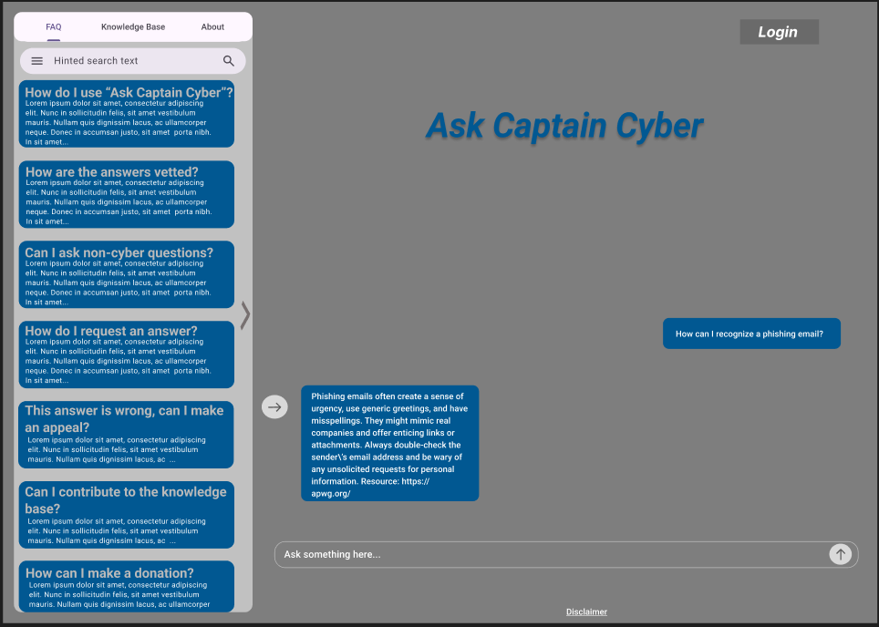

*Figure 1: Figma mockup of “Ask Captain Cyber”*

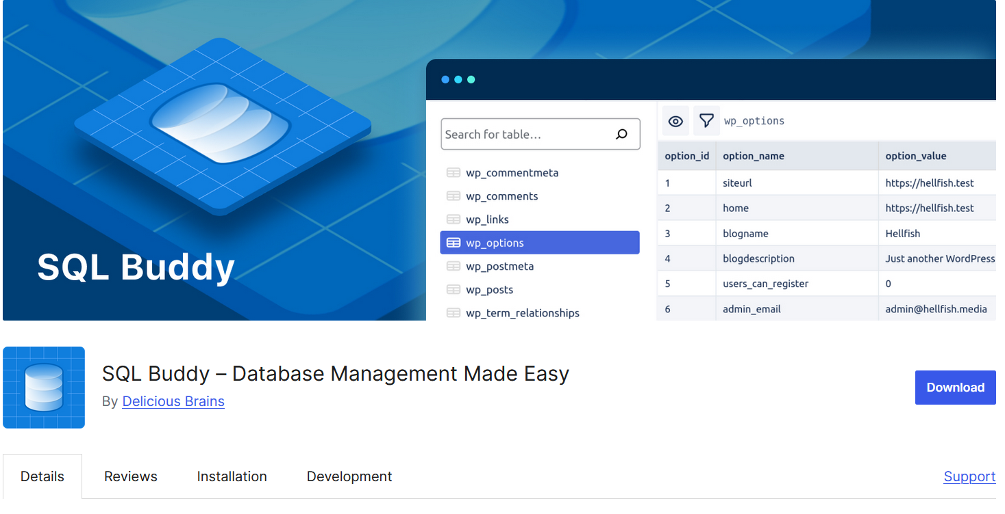

*Figure 2: SQL Buddy Database Plugin*

**Past week accomplishments**

* Ethan Comiskey - Developed a tentative timeline for our project and developed steps for beginning our project implementation
* Steven Ragan - Looked into available data sets/web scrapers we can use to generate responses.
* Alex Elsner - Worked with Casper Run to get a database plugin set up and set up the GitHub repository for the Website, along with running a local instance of WordPress.
* Casper Run - Worked with Alex Elsner to narrow down the database plugin we would like to use and setup the GitHub repository with the WordPress site.
* Alexander Kronau - Created an AI initialization prompt to be used during the startup of our chatbot. Its purpose is to tell the LLM “who” it is (Captain Cyber), its purpose (answer questions about cybersecurity, its allowances (what it can/cannot do), alongside other guidelines it should follow during user interaction.
* Caden Murphy - Built a local copy of the website on my machine with WP Local. Found source code and began understanding how it is currently built and how to transition into our ideal “Ask Captain Cyber”

**Individual contributions**

| **NAME** | **Individual Contributions**  *(Quick list of contributions. This should be short.)* | **Hours this**  **week** | **HOURS**  **cumulative** |
| --- | --- | --- | --- |
| Ethan Comiskey | Developed tentative timeline/list of steps | 6 | 38 |
| Steven Ragan | Looked into data sets/ web scrapers | 6 | 38 |
| Alex Elsner | Database plugin setup, local setup, and Github Repo setup. | 6 | 38 |
| Casper Run | Database plugin research and GitHub Repo Setup. | 6 | 38 |
| Alexander Kronau | Developed the AI initialization prompt that explains to Captain Cyber what it can, should, and should not do. | 6 | 38 |
| Caden Murphy | Researched React-based Headless CMS to transition from WordPress frontend to React. | 6 | 38 |

**Plans for the upcoming week**

* Ethan Comiskey - Assess existing backend implementation in git to figure out how future changes can be made for our project
* Steven Ragan - Start on some sort of front-end interface through WordPress
* Alex Elsner - Start setting up the database for the users. Start researching how the ambassadors will work in the backend (admins, pretty much). Start looking into if we need to create any custom plugins ourselves.
* Casper Run - Start setting up the database for users with Alex Elsner. Research the WordFence firewall and start configuring it to fit the project. I suggested to the team that we should contact the University of Iowa about their helper bot that Doug sent us as a potential resource.
* Alexander Kronau - Create a detailed mockup for the expert interface designed to evaluate LLm-generated questions. This will be completed in Figma and will allow for continued progress of the front-end implementation.
* Caden Murphy - Continue research and implementation of WordPress to React Frontend based on the provided source code